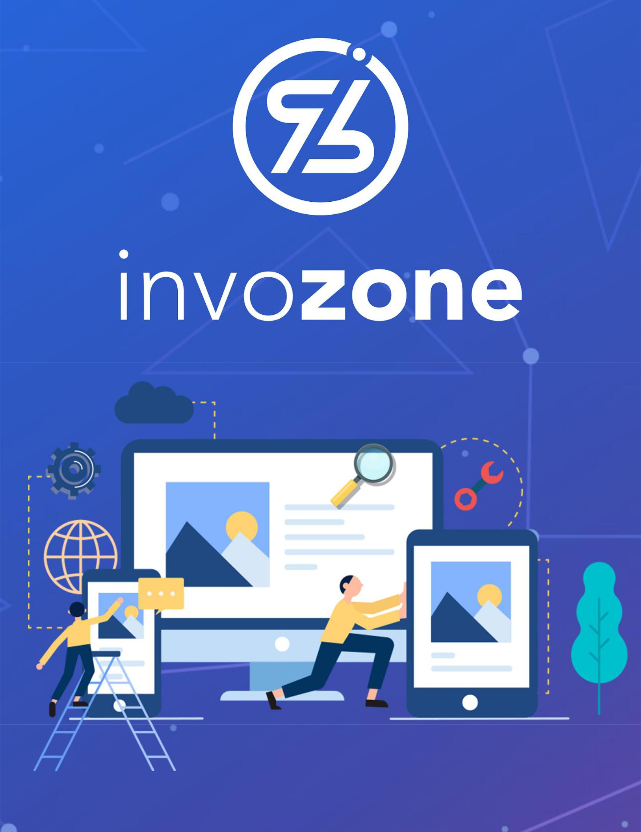

Platforms and Use Cases

READING TASK | 3

## Last Updated: December 29, 2021

# Platforms and Use Cases

## Benefits and Risks of Cryptocurrencies

The below articles explains the advantages and disadvantages of crypto currencies. Read them thoroughly.

<https://www.angelone.in/knowledge-center/cryptocurrency/pros-and-cons-of-using-cryptocurrency>

<https://www.thesecurityblogger.com/risks-and-benefits-of-investing-in-cryptocurrencies/>

<https://www.bbva.ch/en/news/cryptocurrencies-benefits-and-risks-of-virtual-currencies/>

## Blockchain Platforms

Below links explains the different types of blockchain platforms:

* Ethereum
* Corda
* Hyperledger
* Ripple
* EOS
* Others

Study the consensus, blockchain ledger, and details of each blockchain.

<https://www.leewayhertz.com/blockchain-platforms-for-top-blockchain-companies/>

<https://geekflare.com/finance/blockchain-platforms-for-finance-applications/>

## Use Cases & Applications

Mentioned below are the use cases of Blockchain in multiple industry sectors, please view with your own convenience in order to get an idea of how it can be used in certain business use cases.

* Cryptocurrency
* Tracing Food
  + [COFFEE](https://www.youtube.com/watch?v=YOr9A_TygBk)
  + [SEAFOOD](https://www.youtube.com/watch?v=8nrVlICgiYM)
  + [Walmart](https://www.youtube.com/watch?v=SV0KXBxSoio)
* E-Commerce
  + [CyberMiles](https://www.youtube.com/watch?v=o3SE_DV9iTs)
* [Oil n Gas](https://www.youtube.com/watch?v=i2R_N-QTAtM)
* [Energy Sector](https://www.youtube.com/watch?v=AFdV530ZkWA)